Circuit Schematic:

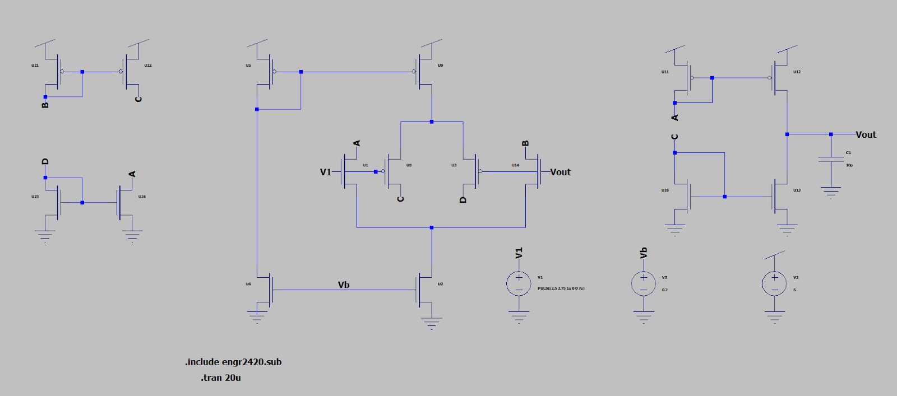

Simulation results for different V1’s:

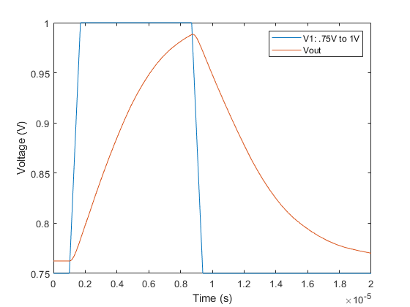

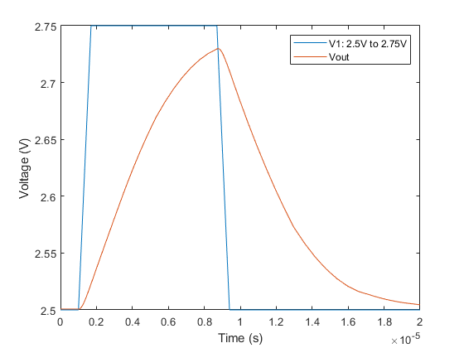

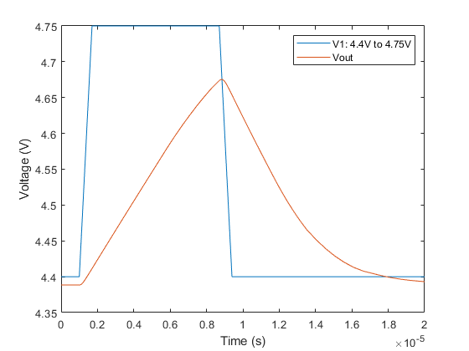

The time constant of the circuit near the rails should be similar, while the time constant in the middle of the input range should be smaller than these.